# Arduino, Oscilloscope & Computer Setup

## Materials

* 1x Arduino Uno / Arduino Mega
* 1x Adafruit Motor Shield
* 10x Breadboard wires
* 2x Translation Stage (with Stepper Motor) – for 2-D scanning
* 1x 12V power supply
* 1x Code for Arduino IDE (communicate to python) - software
* 1x Adafruit Motor Shield libraries – software

## Procedure

1. Stacked the Adafruit motor shield on top of the Uno / mega, matching the pins

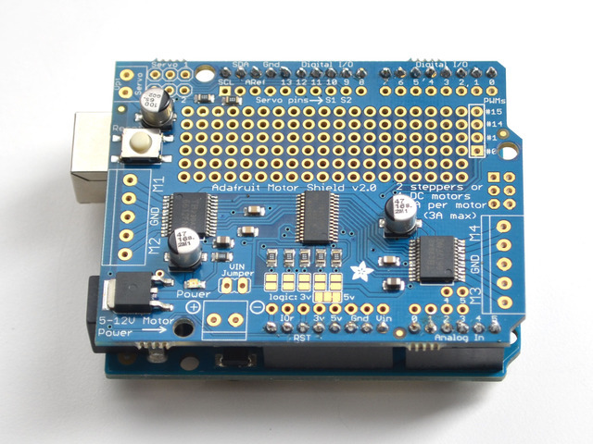

1. Connected Motor to shield

Connecting

Wires

Connecting

Wires

Motor Wires

Motor Wires

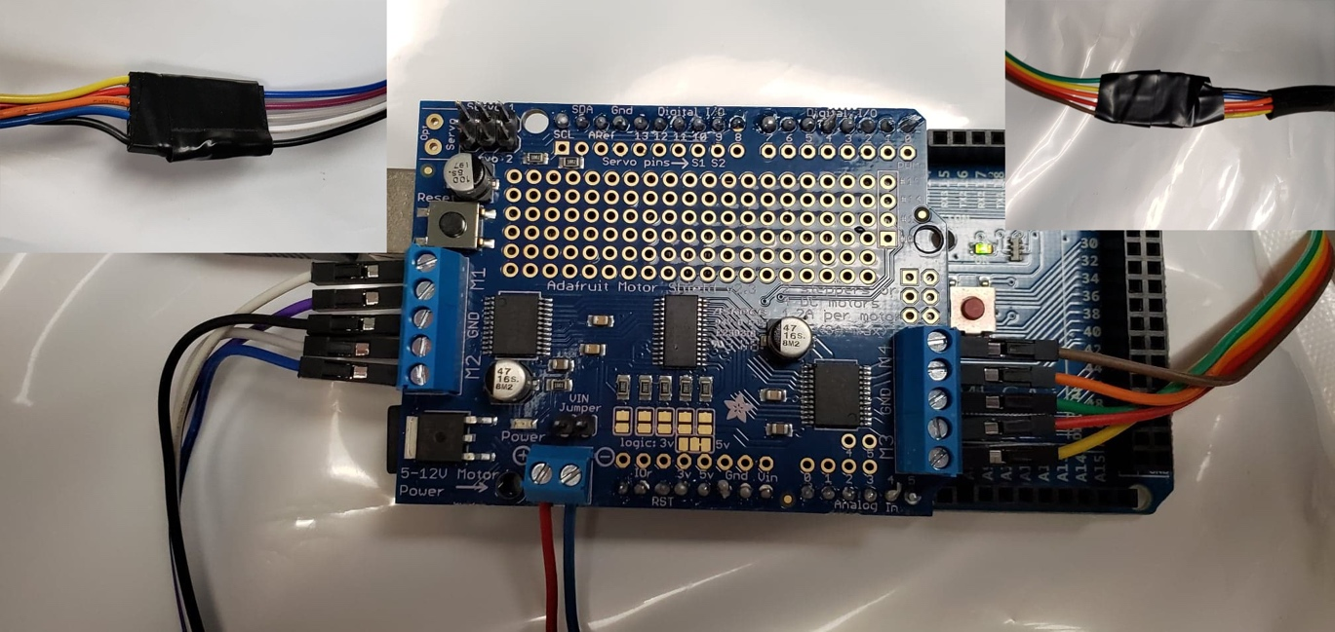

12V Power Input

Table 1: Wiring Diagram for Step 2

|  |  |  |
| --- | --- | --- |
| Motor Wire Color | Connecting Wire Color | Shield Position in photo (Top Down) |
| Blue | White | M1 (top) |
| Red | Purple | M1 (bot) |
| Black | Black | Ground (left) |
| Orange | Gray | M2 (top) |
| Yellow | Blue | M2 (Bot) |
| Yellow | Brown | M4 (top) |
| Orange | Orange | M4 (bot) |
| Black | Green | Ground (right) |
| Red | Red | M3 (top) |
| Blue | Yellow | M3 (bot) |

1. Powered with 12V power supply on shield power & connected to computer via USB

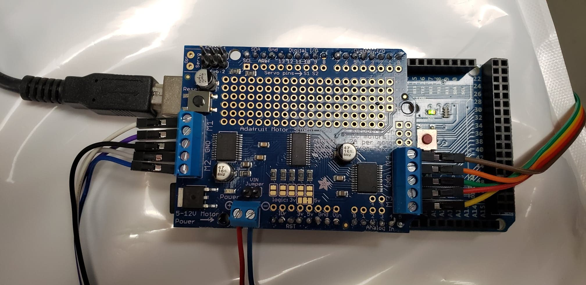

1. Downloaded, Opened Arduino IDE, Installed Adafruit_motorshield.h and upload file “Stepper_setup_for_py.ino”

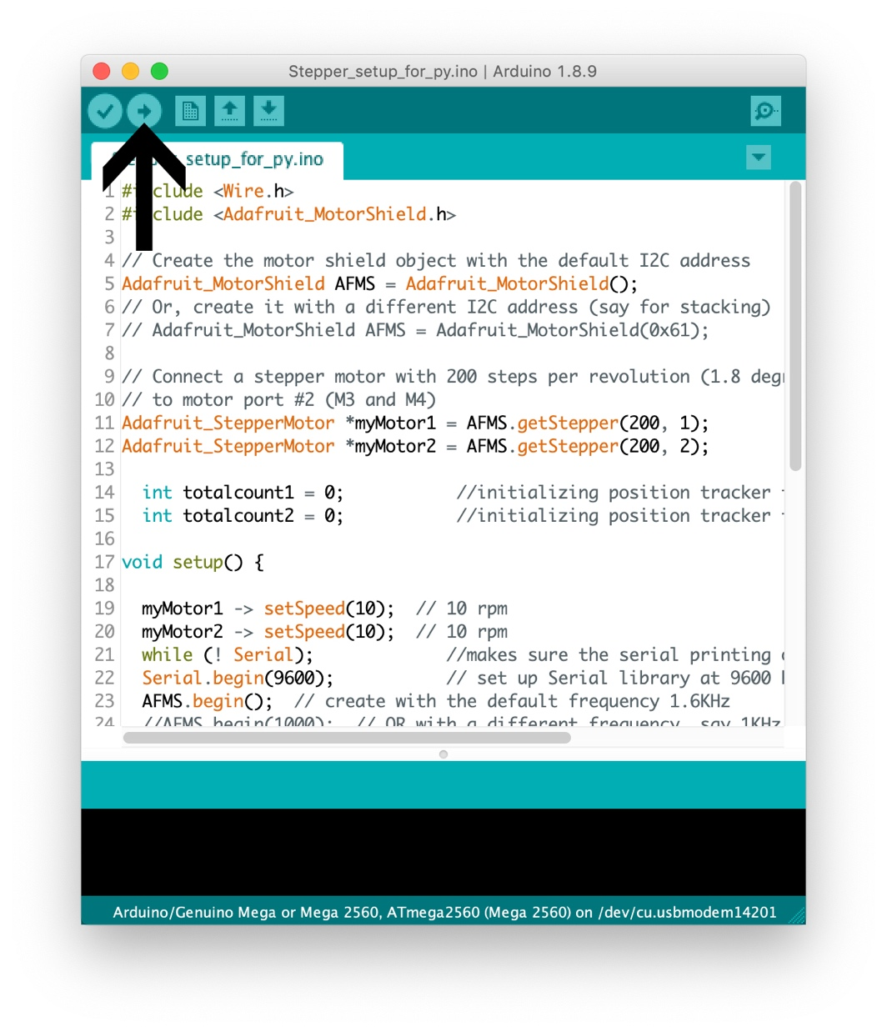

**NOTE: FROM THERE THE ARDUINO SIDE IS COMPLETE. TO USE CONTINUE ON PYTHON**

1. Install Anaconda with Python version 3.7

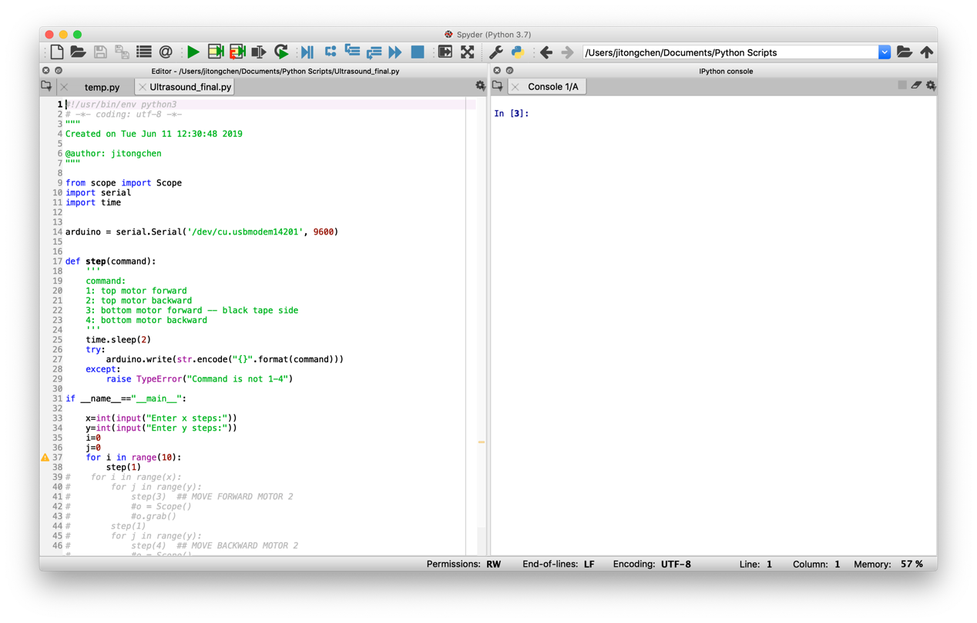

1. Install “pyserial” & “pyvisa” (link – Pyvisa / pyserial installed via pip or conda in Anaconda prompt)

<https://pyvisa.readthedocs.io/en/stable/getting_nivisa.html?fbclid=IwAR2l2jMVNuB0RRPi1JOE3TlfNQccP4DBaciYMjcj5ukP0hYJidBmgxn_ui0>

Install the VISA backend, National Instrument’s NI-VISA 17.5

<https://www.ni.com/en-za/support/downloads/drivers/download.ni-visa.html#305862>

1. Connected Oscilloscope to computer through USB and turned device on
2. `VISA_ADDRESS` is the unique address of the oscilloscope being used; it can be found via pyvisa (see link to documentation above) or via the oscilloscope. `VISA_PATH` is a path that leads to the visa32.dll installed by NI-VISA 17.5. Modify this to fit other operating systems. Scope class takes `directory` parameter, which is a path to the directory in which to save the oscilloscope data.

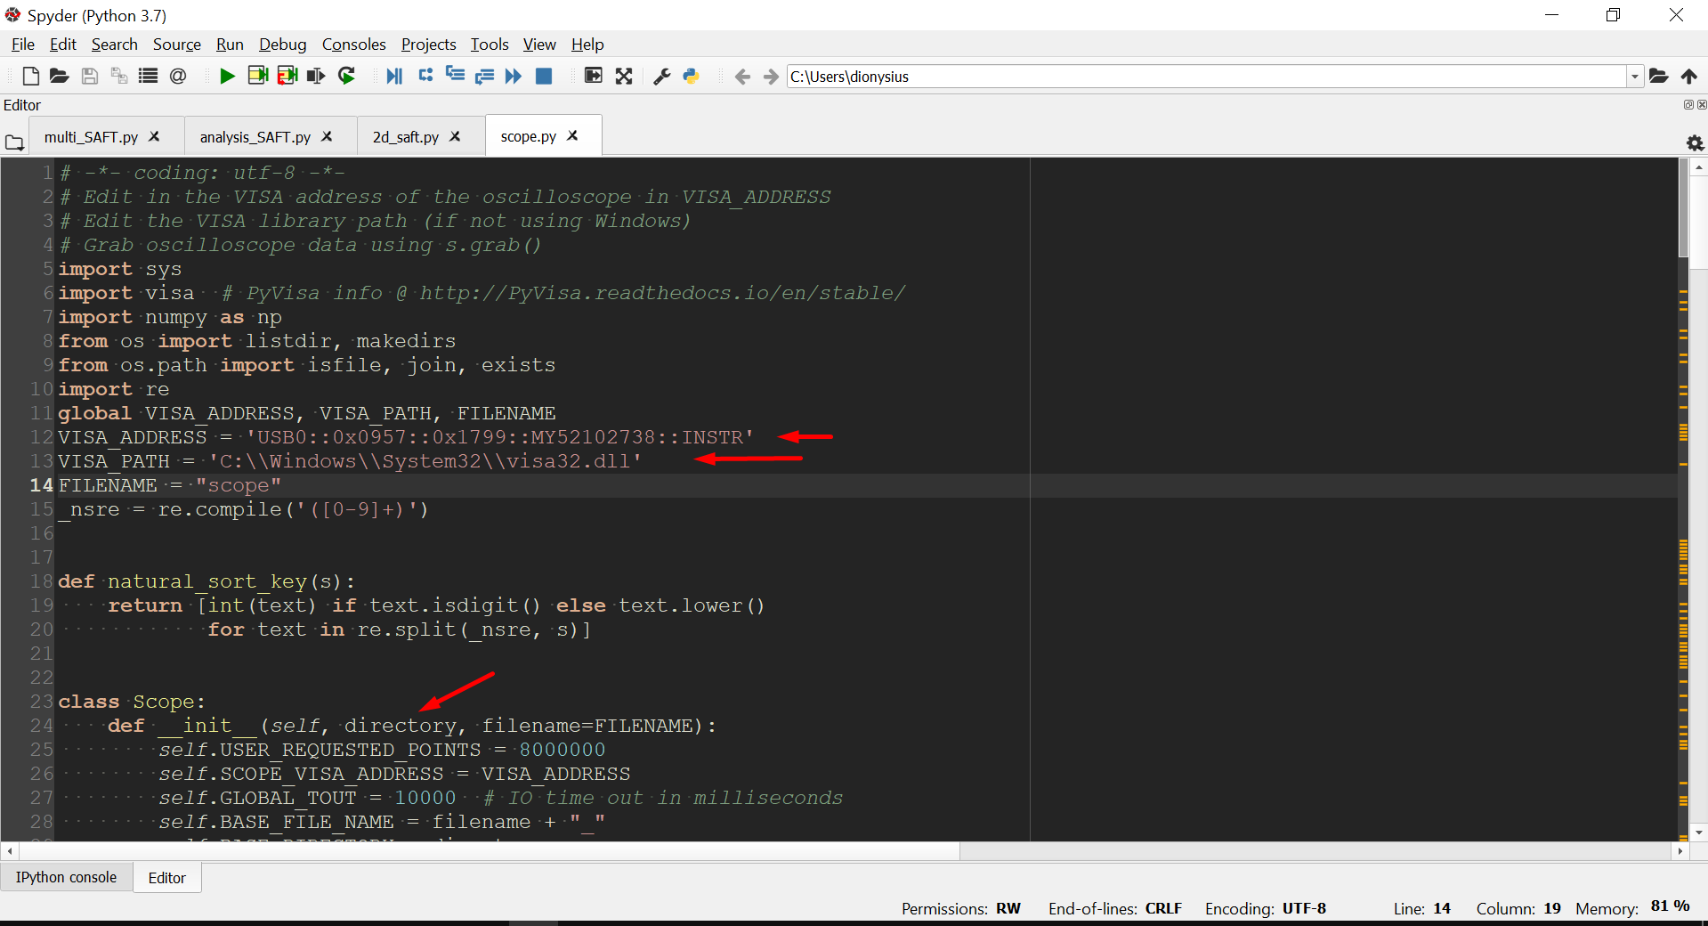

1. scope.py is run as a main program for manual Angle Dependence experiments. The Scope class is imported into other programs to collect data, such as scanning.py which performs a scan over a grid domain